# 1. Android application project: BLE remote controller application

This project is to develop an Android based BLE remote controller application for PAYG module. This remote controller application will act as an BLE input device (BLE peripheral device /server) of PAYG module.

**1.1. Introduction**

PAYG module is a module that consists of PAYG firmware running on a STM BlueNRG-2 chipset. The main functionality of this PAYG module is to control (activate/deactivate) application device based on credit balance stored in module.

It receives encrypted code from input devices (RF remote keypad / physical keypad / BLE remote controller application) and perform decryption on the code received. The decrypted code will unveil the tasks to perform on the module such as update credit balance (number of days), reset system, unlock system, output system information…etc. based on the decrypted code.

To supply input (ASCII digit codes) to this PAYG module, several methods can be adopted, namely RF communication, physical keypad attached to PAYG module, etc.

In this project, BLE will be used. Hence, an BLE remote controller application will be developed in order to send and receive data from the PAYG module.

**1.2. Objective**

* Design an Android based application (with GUI) that is able to send data to and receive data from client device (PAYG module).

**2. BLE application: Specification**

Develop the product with the following specifications:

An Android based BLE application that allows sending data (in ASCII form) to, receiving data from the client device (PAYG module). A GUI is to be developed for the user to supply ASCII text (0 - 9) to the client device.

The main feature of this application is to act as a remote controller device (peripheral/server device) of PAYG module with the use of BLE custom service and characteristics exposed by the server. Custom BLE service and characteristics will be discussed in **Section 3.1**.

**Note:** *GUIs in Example 2.1 provides just the example GUIs of the basic functionalities, it is up to developer to decide on how the GUI will be presented. However, one must make sure the main features as stated below are included.*

Development platform

* Android (with BLE support)

Data sender

* Ability to send data in ASCII text to the connected BLE client. (Refer to Example 2.1 – BLE-send interface)
* Implement using Characteristic “Send” in **Section 3.1**
* Maximum allowed bytes per transmission should be at least 30 bytes

Data receiver

* Ability to receive data in ASCII text from the connected BLE client. (Refer to Example 2.1 – BLE-send interface)
* Implement using Characteristic “Receive” in **Section 3.1**

Data storage

* Ability to store the history/records of message sent by the client device. (Refer to Example 2.1 – BLE-inbox interface)
* Maximum record size will be 30 messages.

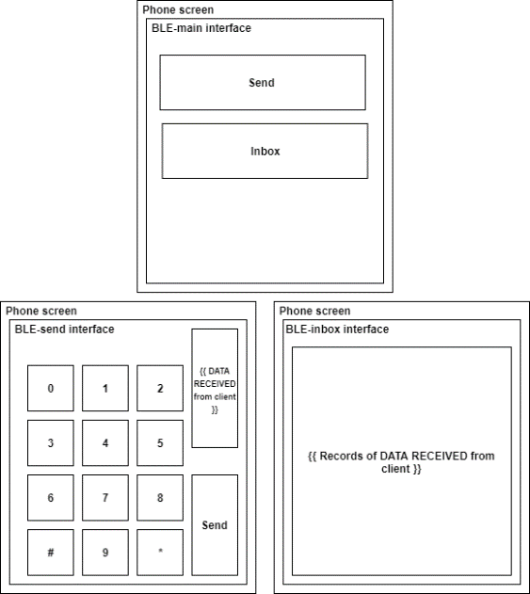

Example 2.1

**3. BLE application: Requirements**

The product designed must meet the following requirements:

**3.1. Custom BLE service and characteristics**

Custom service and characteristics will be needed for the client device to identify the characteristics available on the server device.

Service

* BLE service named “BLE talk” with UUID “6E6765BD6D8C47D8B29A0AF917C78784” must be defined.

Characteristic

* Characteristic named “Send” under service “BLE talk” with UUID “6E6765BE6D8C47D8B29A0AF917C78784” must be defined. Property “notify” and permission “read” must be enabled.
* Characteristic named “Receive” under service “BLE talk” with UUID “6E6765BF6D8C47D8B29A0AF917C78784” must be defined. Property “Write without response” and permission “write” must be enabled.

**3.2. BLE connection**

* Advertise BLE advertisement data at every moment as long as it is turned on to allow the client device to detect and connect to it.
* Advertisement data must contain Complete Local Name data field called “TWP” to allow BLE client identifies and connects to the peripheral.
* Application must be connectable. It must accept any connection that is initialized by the BLE client, no bonding/security is needed.
* BLE client device will initialize the connection to the server device once it detects the existence of the target server device. BLE server will be a passive device waiting for available incoming connection.
* Random address shall be used.

**Extra information**

**PAYG module: General BLE workflow**

**Central role**

**System initialization**

1.) Reset BLE chipset

2.) Write config data to BLE chipset

3.) Set TX power of the BLE connection

4.) Initialize GATT

5.) Initialize GAP

6.) Update GATT characteristic value with device name

**Scanning**

1.) Start GAP general discovery service, search for server’s MAC address with advertisement data with Complete Local Name “TWP”

**Connection**

1.) Create/initialize connection to the server once MAC address with Complete Local Name “TWP” is found.

2.) If L2CAP connection update request is received from the server device, send response to the server device so that service discovery can proceed.

**Service discovery**

1.)Once connection is established, client device will discover the characteristics as specified in **Section** **3.1.**. If characteristics are found, the client device will store the handler and identifier value from the server device, so that data manipulation on these characteristics is possible. As for characteristic “Read”, the client device will enable the notification by writing value (0x0001) to the descriptor of the characteristic “Read” so that server device can notify the client device when there is data. After the service discovery is fully performed, the server device should now be able to write data or receive data from the client device.

**4. Appendix**

|  |  |
| --- | --- |
| Client | PAYG module |
| Central |
| Server | BLE remote controller application |
| Peripheral |

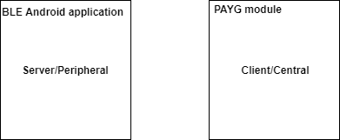

**5. References**

BLE introduction: GATT and GAP, from: <https://learn.adafruit.com/introduction-to-bluetooth-low-energy/>

BLE specifications, from: <https://www.bluetooth.com/specifications/assigned-numbers/>